Studio 11

Name and Student Id: Xin Xu 30421225

Self-Evaluation:

|  |  |  |  |  |  |
| --- | --- | --- | --- | --- | --- |
| Need Help | Work in Progress | Pass | Credit | Distinction | ***High Distinction*** |

Tutor Evaluation:

|  |  |  |  |  |  |
| --- | --- | --- | --- | --- | --- |
| Incomplete | Needs improvement | Pass | Credit | Distinction | High Distinction |

Task 11.1:

{Answers}

Differences between CI and CD:

CI:

1. short-lived feature branches

2. team is merging to master branch multiple times per day

3. fully automated build and test process which gives feedback within 10 minutes

4. deployment is manual

CD:

1. CI + CD + the entire software release process is automated

2. You can develop faster as there's no need to pause development for releases. Deployments pipelines are triggered automatically for every change.

3. Releases are less risky and easier to fix in case of problem as you deploy small batches of changes.

4. Customers see a continuous stream of improvements, and quality increases every day, instead of every month, quarter or year.

{Screenshots}

A screenshot of webpage deployed in the Azure Cloud and URL (with problem)

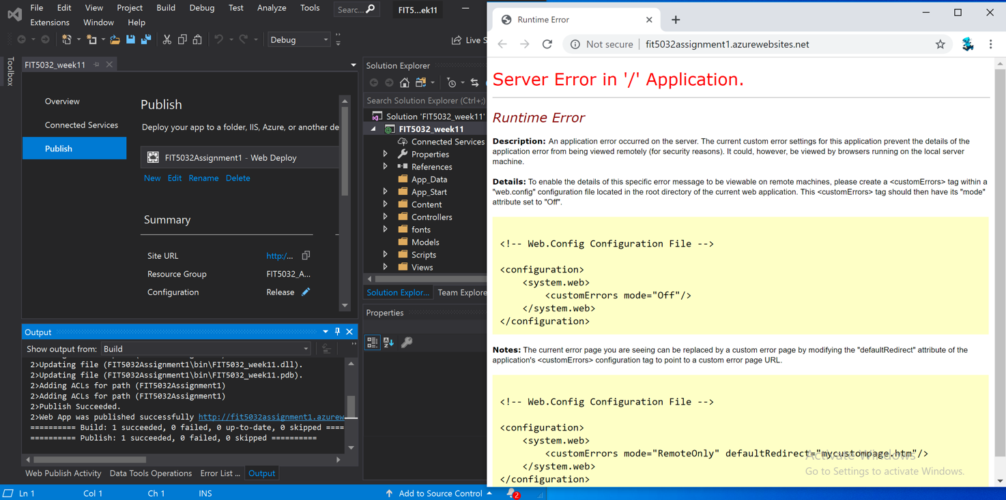

{Link to code repository}

{References}

{URLs}

https://drive.google.com/drive/u/1/folders/1EJm0eM0xhxAZXouHovffv0YsfZgxz1be

Task 11.2:

{Answers}

1. Unit Testing

Unit testing is the first level of testing and is often performed by the developers themselves. It is the process of ensuring individual components of a piece of software at the code level are functional and work as they were designed to.

2. Integration Testing

It is integrated other units to test that are designed to perform specific tasks or activities

3. Performance Testing

Performance testing is a non-functional testing technique used to determine how an application will behave under various conditions.

4. Security Testing

It is used to test the security of each unit and the whole project

5. Usability Testing

Usability testing is a testing method that measures an application’s ease-of-use from the end-user perspective and is often performed during the system or acceptance testing stages.

{Screenshots}

A screenshot of Unit Tests for ASP.NET MVC

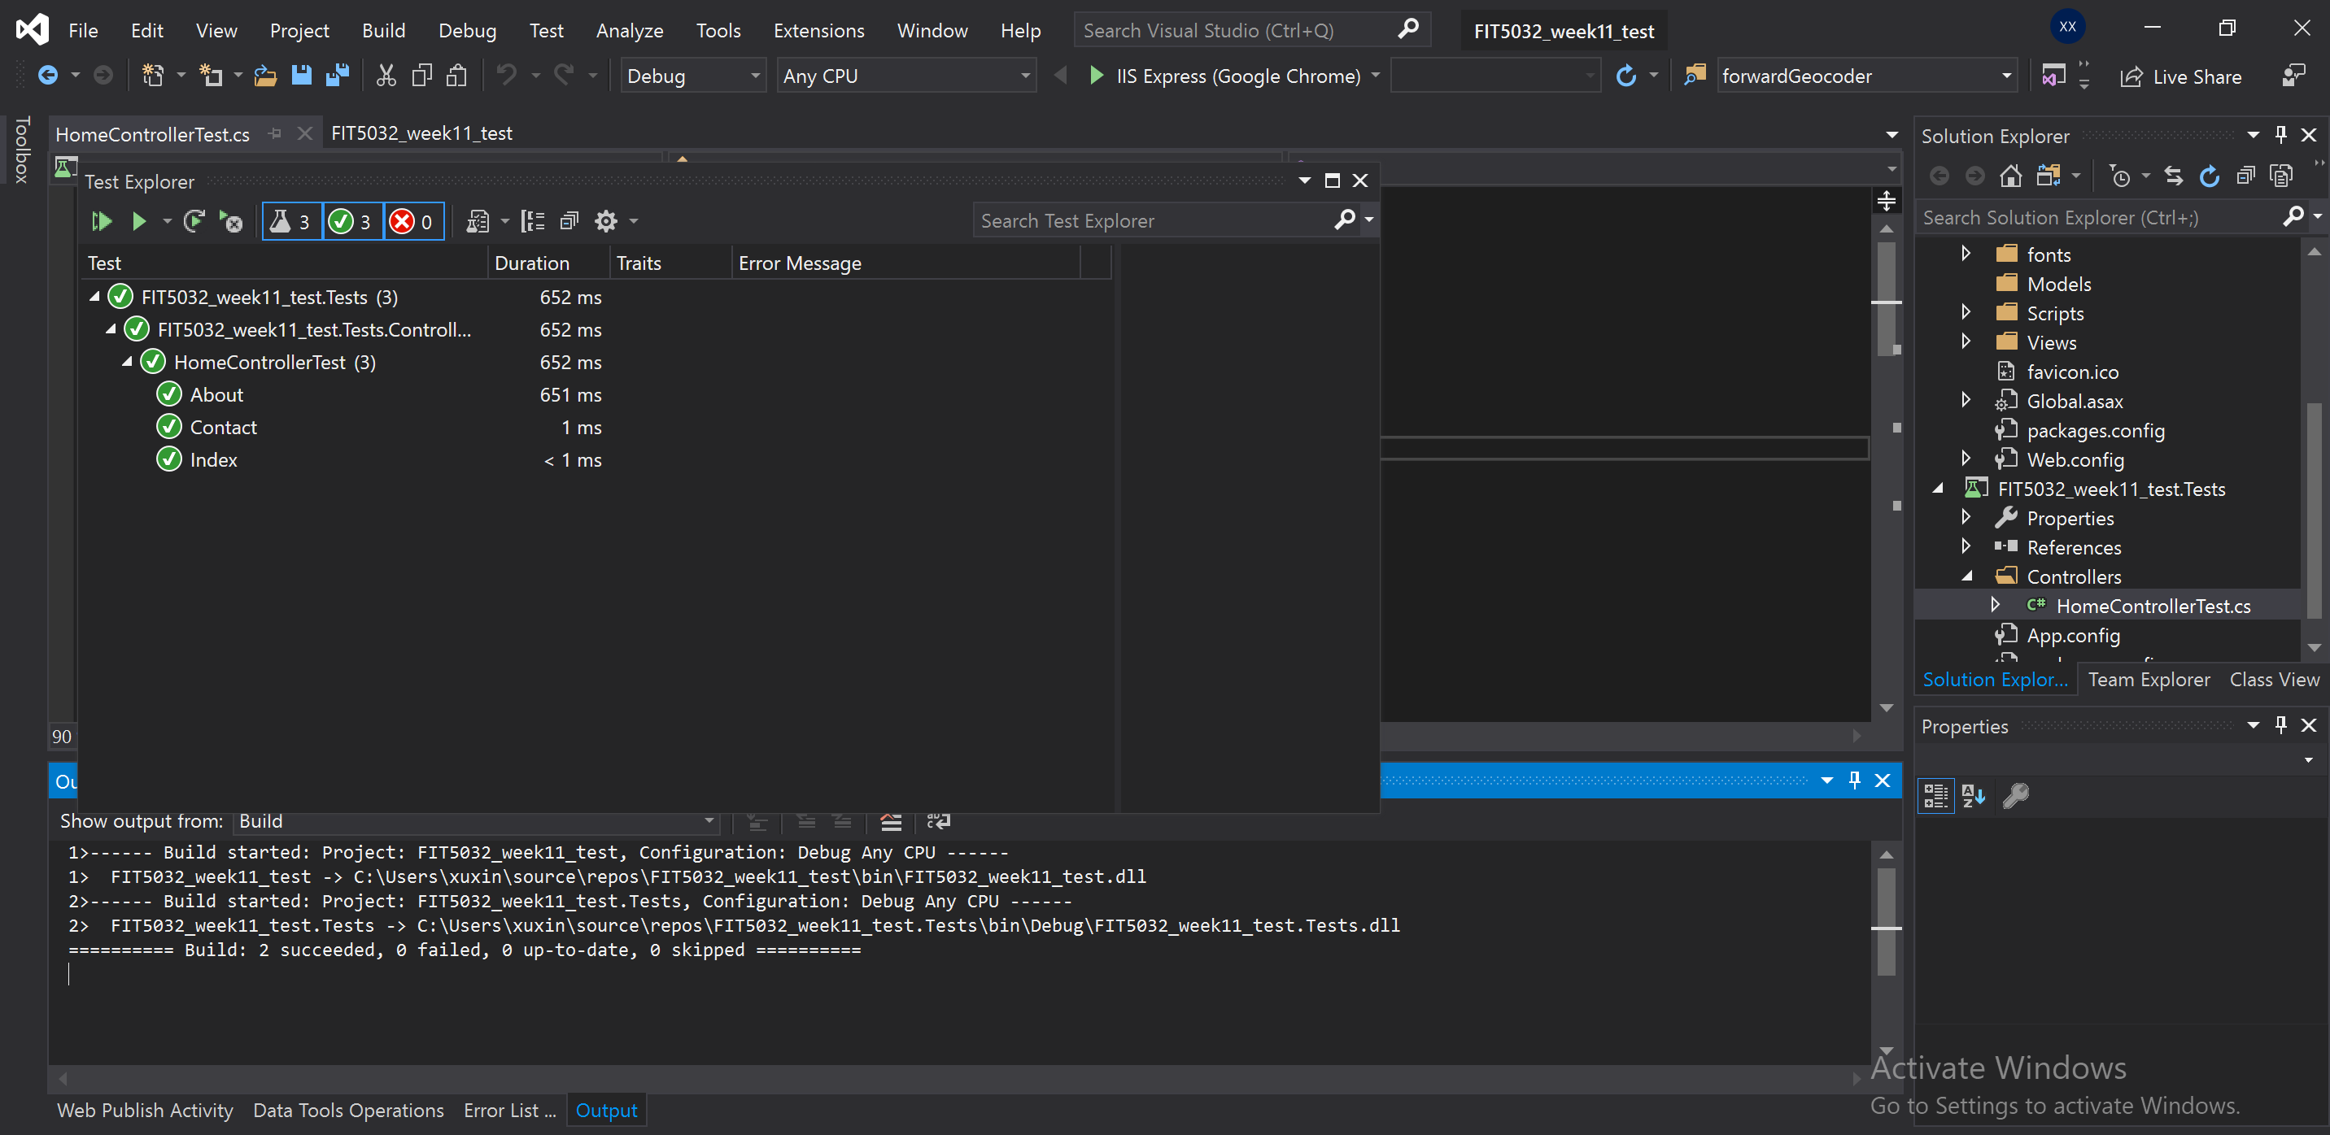

{Link to code repository}

{References}

<https://www.guru99.com/testing-methodology.html>

<https://smartbear.com/learn/automated-testing/software-testing-methodologies/>

{URLs}